HEATING AND COOLING TEST 2

Name: ___________________________________________ (35 marks)

- Non-physics people often use the word heat when then actually mean temperature or even internal energy (thermal energy) of the object. Explain the difference between the three (words in italics).
(3 marks)

_________________________________________________________________________________
_________________________________________________________________________________
_________________________________________________________________________________
_________________________________________________________________________________
_________________________________________________________________________________
__________________________________________________________________________________________________________________________________________________________________
- Explain why supermarket freezers still manage to keep the contents frozen despite often having no lids. (3 marks) _____________________________________________________________________
_________________________________________________________________________________
_________________________________________________________________________________
_________________________________________________________________________________
_________________________________________________________________________________
_________________________________________________________________________________
_________________________________________________________________________________
- People in hot arid regions frequently store water in porous canvas bags through which some of the water can seep. What is the purpose of doing this and how is the purpose achieved? (3 marks)

_________________________________________________________________________________
_________________________________________________________________________________
_________________________________________________________________________________
_________________________________________________________________________________
_________________________________________________________________________________
_________________________________________________________________________________
__________________________________________________________________________________________________________________________________________________________________
- Explain, with examples, the difference between a high grade energy forms and a low grade energy form. (3 marks) __________________________________________________________________
_______________________________________________________________________________
_______________________________________________________________________________
_______________________________________________________________________________
_______________________________________________________________________________
__________________________________________________________________________________________________________________________________________________________________
- What is the specific heat of an alloy if it requires 3.20 x 10⁴ J of energy to heat 1.20 kg of the alloy from 15.0 ⁰C to 92.5 ⁰C? (2 marks)

- A laboratory technician was trying to find the latent heat of fusion of an alloy she had created. She found that she needed to add 6.84 x 10⁵ J of energy to 1.95 kg of the alloy to fully melt it. Find the latent heat of fusion of the alloy. (2 marks)

- A small espresso coffee machine contains 0.500 kg of water at 20.0⁰ C. How much energy is required to change the water into steam at 100.0⁰ C? (3 marks)

- A 3.50 x 10³ watt kettle holds 750.0 mL of water at 20.0⁰C. How long in minutes will it take to boil the water totally away? (3 marks)

- Alan wants to add the exact amount of ice to his 250.0 mL drink (specific heat 3.99 x 10³ J kg⁻¹ K⁻¹) to cool it from 36.0⁰C to 7.00⁰C. The ice comes from the freezer where it is kept at a temperature of -6.00⁰C. Assuming the cup used is fully insulated, how much ice must he add? (3 marks)

- How much steam at 107⁰C must be added to 50.0 g of ice at -4.00⁰C in an insulated aluminium calorimeter of mass 47.0 g so that the ice just melts. (4 marks)

- On a cold morning, the metal handlebars on a bike feel colder than the rubber grips. This is mainly because:
    - Rubber is a better absorber of radiation than the metal.
    - The metal is colder than the rubber.
    - The rubber has a higher specific heat capacity than the metal.
    - Metal is a better radiator of heat than rubber.
    - Metal is a better conductor of heat than rubber.

Answer: __________________ (1 mark)

- The graph below represents the heating curve for an unknown metal. Energy is added to 10.0 g of the solid metal initially at a temperature of –39⁰C, until the metal evaporates (graph not to scale).

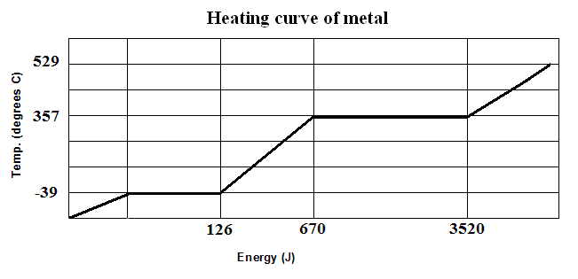
  - What is the boiling point of the metal? (1 mark) _________________________
  - What is the latent heat of vaporisation of the metal? (2 marks)

- In a refrigerator, a pump is continually causing 100 g of liquid freon to evaporate then condense for every stroke is makes. The evaporation takes place inside the refrigerator and the condensation outside, so that heat is continually being extracted from the refrigerator cabinet. If the latent heat of vaporization of the liquid is 2.50 x 10⁵ Jkg⁻¹ and the pump makes 75 strokes per minute, calculate (assuming no temperature change of either the liquid freon or the gas) the amount of heat energy extracted by each stroke of the pump. (2 marks)

